Dorjee Tso

B-3, Tibetan Colony

Clement Town, Dehradun

Uttarakhand

November 11, 2022

The FRRO

Foreigners Registration Office,

Dehradun, Uttarakhand

**Subject: Request Letter regarding Return Visa**

Sir/Madame,

With warm regards, I would like to request your kind self to issue me a Return Visa. It’s a dream come true to tour Thailand from November 13, 2022 to November 20, 2022. So, kindly support and help me for issuing Return Visa.

Thanking you

Your faithfully,

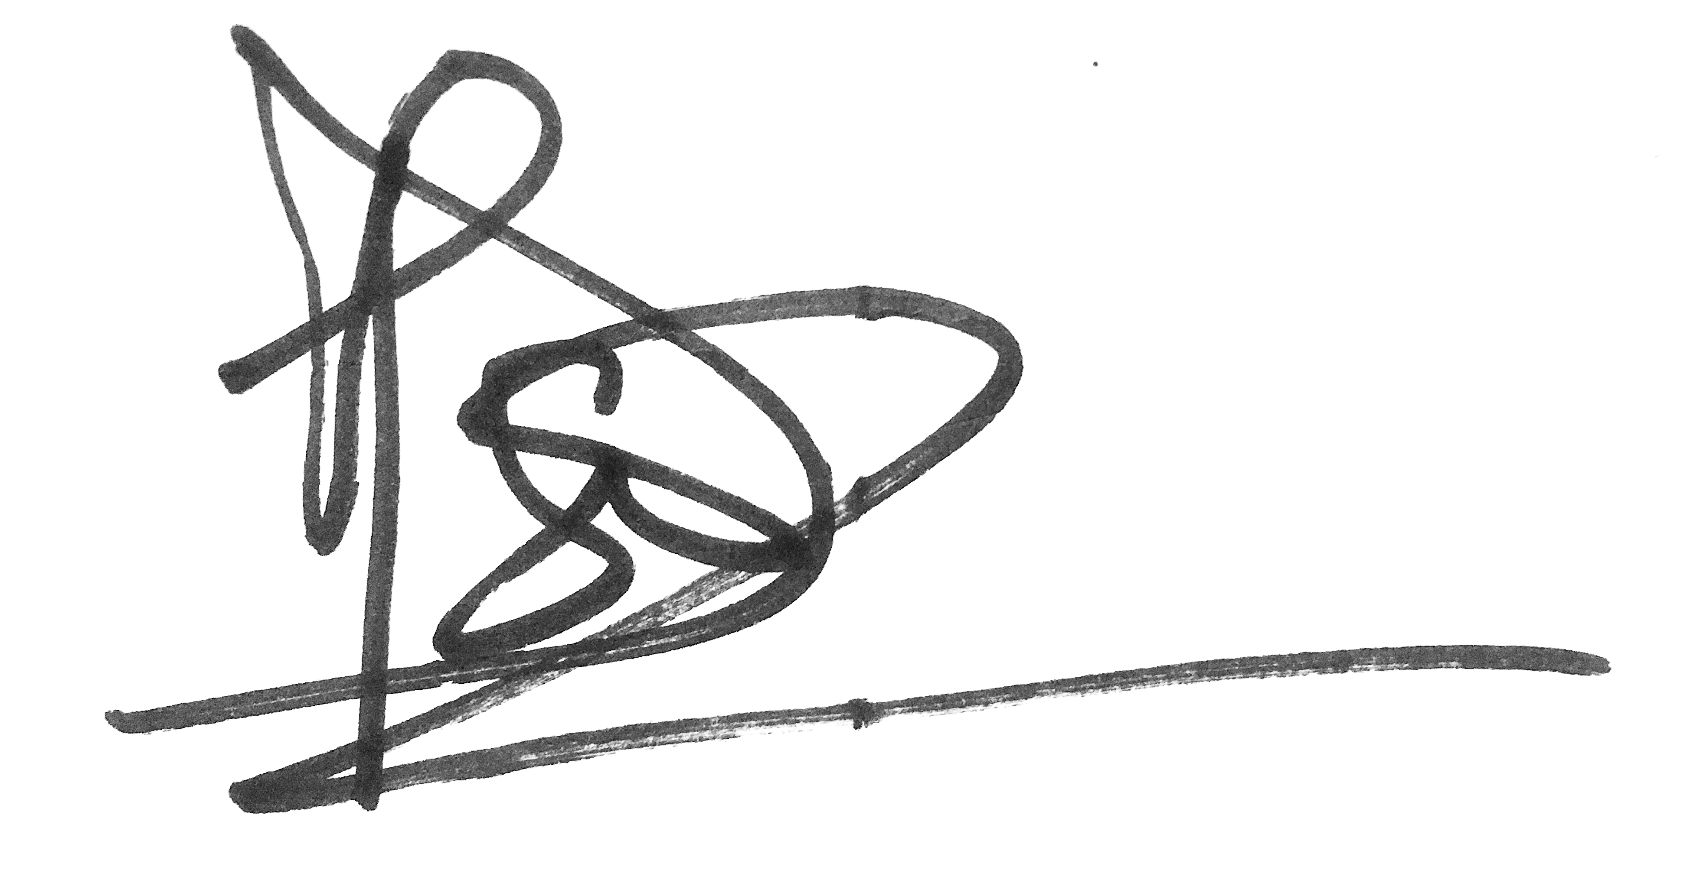

Dorjee Tso